Components :
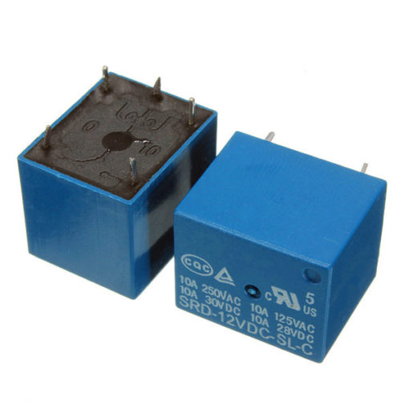
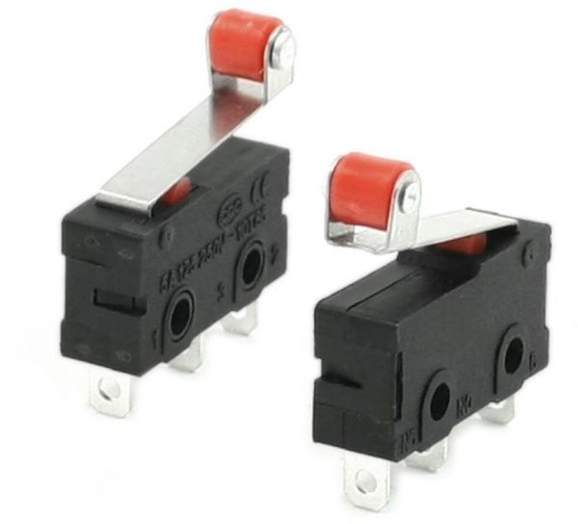
1- Limit switch 2- Relay 12V 5 pins

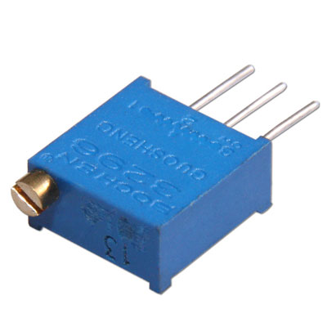
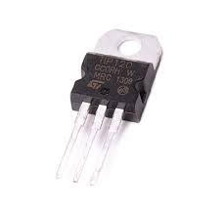
3- Tip 120 4- Trimmer

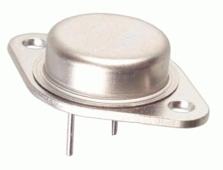
5- 7805 Regulator Metal 6- Capacitor Polarized
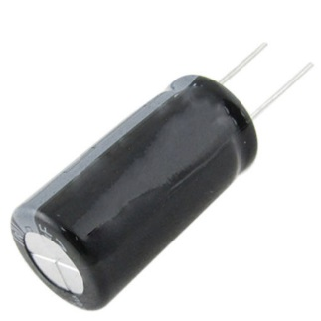

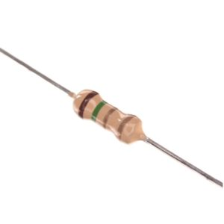
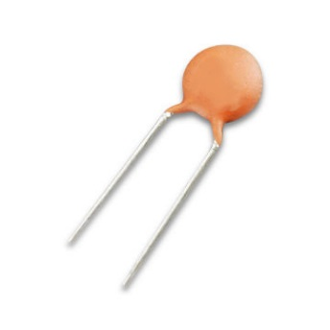
7- Capacitor non polarized 8- Resistors

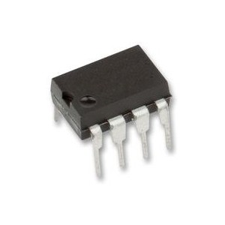
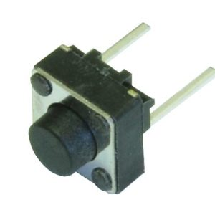
9- pushbutton 10- 555 timer

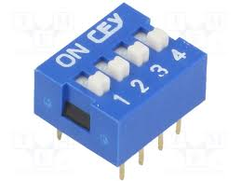
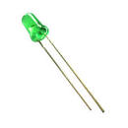
11- 4switch (DS04) 12- Green led 5mm

13- Adapter 12 V 14- UV adapter with switch
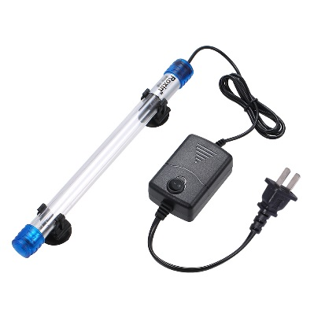
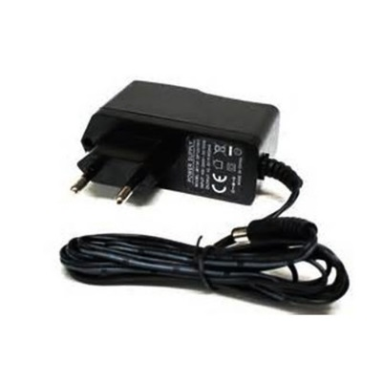

15- Xt60 connector 16- jack adapter
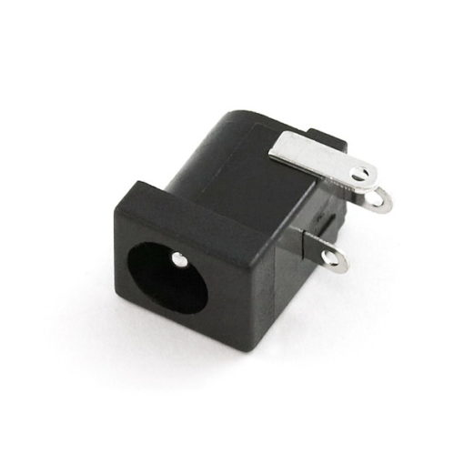
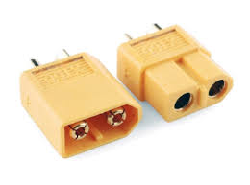

Connections:
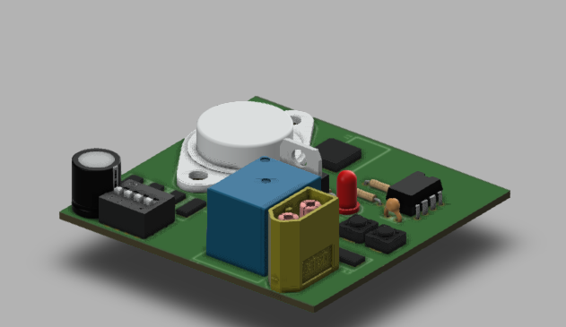
First of all the PCB is assembled as follows :
Make sure to adjust the trimmers values to the following :
First trimmer 273Kohm
Second Trimmer 545K ohm
Third Trimmer 818K ohm
Fourth Trimmer 1.6M ohm
Note : those values may change if the practical value of the capacitor change from 1000uf and the trimmers are adjusted to reach the desired time for the delay and then they can be soldered to the circuit and be controlled by the switches.
Second the 12v DC adapter is connected to the jack adapter in the circuit to provide the DC source .

Then the UV adapter will be opened and the switch will be removed the wires which were connected to that switch will be connected to XT60 connector so it can be connected to the PCB safely.
After that the circuit is finished and it's ready to function.
The Goal of the product:
The circuit will control the time where the UV light will be on or off .
Once you press the start button after you adjust the time using the right switch for the right time then the UV light will be turned on for the amount of time you've chosen .
If you want to stop the circuit , hit the Reset button and it'll stop .
If you press on the Limit Switch , the UV light will be turned off but be careful if you let go of that switch and the timer is still on once you remove your hand from the switch the circuit will automatically light up the UV light .
Note: put the right values of the resistors and capacitors in place , make sure to connect everything as mentioned or any malfunction will be on you .
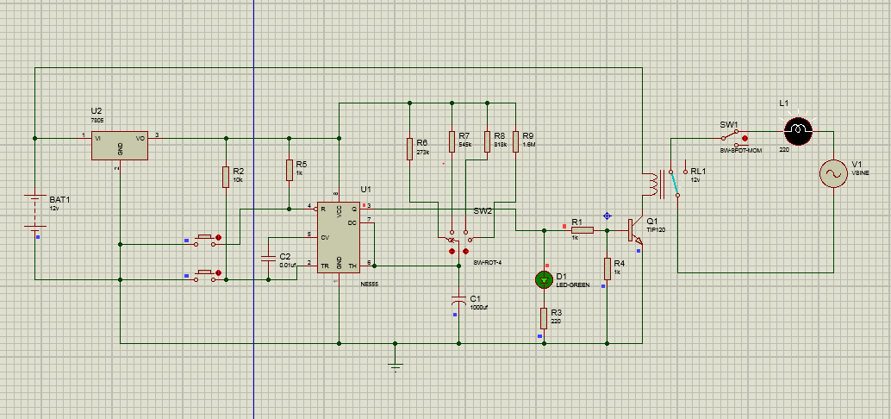
Circuit diagram

